CAMPUS FOOD DELIVERY & ORDER MANAGEMENT SYSTEM
GROUP 18 PROJECT REPORT
Fundamentals of Programming Coursework
GROUP 18 MEMBERS
1 | BAMWESIGYE RONNIE VU-BSF-2603-1322-DAY
2 | KHATINDI JAMES VU-BCD-2603-2513-DAY
3 | NANSIKOMBI LILLIAN VU-BIT-2603-0865-DAY
4 | BASEMERA HILDA VU-BIT-2603-0399-DAY
5 | NALWANGA SARAH VU-BCS-2603-2447-DAY
6 | KATO MICHAEL JOHN VU-DIT-2603-0133-DAY
7 | BUBA MONDA ALEX VU-BBC-2603-1999-DAY
8 | KITUMAINI MUKENGERE FRANK VU-BBC-2603-3684-DAY

1. Introduction
The Campus Food Delivery & Order Management System is a Python-based console application designed to support the daily activities of a campus canteen. The system provides a simple menu-driven interface through which a canteen attendant can view available food and drinks, take customer orders, assign riders, update order status, view all recorded orders, generate a daily sales report, save the order log, and safely exit the application.
The project was developed as a practical application of programming concepts covered in class. The system demonstrates the use of functions, variables, conditional statements, loops, lists or structured records, input validation, file handling and a menu-driven program structure. The main aim was to produce a usable system rather than isolated pieces of code. Each module was therefore connected through a central looping menu so that the user can perform several operations during one program session.
The completed system was tested using sample orders to confirm that the major functions work together correctly. During testing, orders were created, quantities were entered, totals were calculated, riders were assigned where appropriate, order statuses were managed, sales were summarised and the order log was saved successfully.
2. System Design and Structure
The system follows a modular design. Instead of placing all operations inside one large block of code, the application separates major activities into functions. This makes the program easier to understand, test, maintain and improve. The central menu acts as the driver of the application and repeatedly asks the canteen attendant to choose an operation.
The main modules represented in the system are the menu module, new-order module, rider assignment module, order-status module, order viewing module, sales-report module and file handling module. The menu module displays the available options and controls the flow of the program. The new-order module displays the canteen menu, accepts item names and quantities, calculates the subtotal and adds the delivery fee before recording the order.
The rider assignment module contains a set of available riders and allows a valid rider to be linked to an eligible order. The order-status module controls the progression of an order through its delivery stages. The view-orders module provides a consolidated view of recorded orders, including their status, items, totals and rider information. The sales-report module uses the stored order information to calculate delivered-order revenue, identify the best-selling item and count orders according to their current status.
3. Main Functionalities
3.1 View Menu
The View Menu function displays the products available from the campus canteen together with their prices. The tested menu contains drinks such as Soda (500ml), Bottled Water and Fresh Juice; meals such as Chicken & Rice, Beef Stew & Posho and Vegetable Pilau; and snacks such as Rolex, Chapati and Samosa. This gives the attendant the information required before taking a customer's order.
3.2 Taking a New Order
The Take a New Order function allows the attendant to select items and enter the required quantity. During testing, Chicken & Rice was selected with a quantity of two. The system calculated a subtotal of 30,000 for the two meals and added a delivery fee of 3,000, producing a total of 33,000. The order was then stored as a new order with an order number and a corresponding status.
3.3 Assigning a Rider
The Assign a Rider function displays available riders, including Brian, Grace, Moses and Patience, and allows the attendant to associate a rider with an eligible order. The system also demonstrates validation by preventing a rider from being assigned to an order that is already in the Delivered state. During testing, an attempt to assign a rider to delivered Order #1 produced a clear message explaining that the order could not be assigned from that state. This is an example of defensive input and state validation.
3.4 Advancing Order Status
The system supports the management of an order's delivery progress. Orders can be monitored as they move through the appropriate delivery states, allowing the attendant to keep the order record consistent with what is happening operationally. Status management is important because the daily sales report uses delivered orders when calculating revenue.
3.5 Viewing All Orders
The View All Orders function displays the recorded orders in a compact form. During testing, the system displayed Order #1 as Delivered with Chicken & Rice x2 and Soda (500ml) x1, with a total of 35,500 and rider Brian. It also displayed Order #2 as Pending with Chicken & Rice x2, a total of 33,000 and an unassigned rider. This confirms that the application retains different orders and presents their current states clearly.
3.6 Daily Sales Report
The Daily Sales Report summarizes important sales information. In the test run, the report showed total revenue from delivered orders of 68,500, identified Chicken & Rice as the best-selling item, and reported two Delivered orders, with zero Pending and zero Out for Delivery orders at that point in the test data. The report provides a quick overview that would help a canteen attendant or manager understand the day's recorded performance.
3.7 Saving and Loading the Order Log
File handling was included so that completed order records are not lost when the program closes. The system saves the order log to a file and loads saved records when the program starts. During testing, the terminal displayed messages confirming that the order log was loaded from the file and later saved successfully. File errors are handled through the program's validation and error-handling approach rather than allowing the application to terminate unexpectedly.
4. Input Validation and Error Handling
Input validation is an important part of the application because a canteen attendant should not be able to accidentally corrupt the order records by entering invalid data. The system checks inputs such as menu choices, order numbers and quantities. For example, when an invalid order number was entered during rider assignment, the program responded with a message requesting a whole number greater than zero. This prevents inappropriate values from being used in later processing.
The system also checks the state of an order before performing operations. A delivered order cannot be assigned a rider again, as demonstrated during testing. These checks improve the reliability of the application and provide useful feedback to the user instead of silently performing an incorrect operation.
5. Testing and Evidence
The system was tested step by step using the console interface. Testing began by running the Python program and confirming that previously saved records could be loaded. The View Menu option was then checked to ensure that the canteen products and prices were displayed. A new order was created by selecting Chicken & Rice and entering a quantity of two. The resulting subtotal, delivery fee and total were checked against the expected calculation.
The order-management functions were subsequently tested. The View All Orders option was used to confirm that both the previously recorded and newly created orders appeared in the system. The rider assignment function was tested with valid and invalid inputs, including an attempt to assign a rider to a delivered order. The sales report was then generated to confirm that revenue, best-selling item and order-status counts were calculated from the stored data.
Finally, the Save Order Log option was used and the program displayed a successful save message. The Exit option was then selected, causing the program to save the order log and display a Goodbye message before returning to the PowerShell prompt. Screenshots of these steps are included in the answer sheet as evidence of system operation.
6. Division of Work Among Group Members
The project was completed as a group, with responsibilities divided among members according to the different system components. The allocation below should be completed with the actual names of the group members before submission. Each member should also be prepared to explain the section they contributed and understand how that section connects to the rest of the system.
Group Member | Primary Responsibility | Contribution
Member 1: NALWANGA SARAH | Order/menu functions | Menu display and taking new orders
Member 2: KHATINDI JAMES | Rider and status management | Rider assignment and order-status updates
Member 3: BAMWESIGYE RONNIE | Reports and records | View orders and daily sales report
Member 4: BASEMERA HILDA | File handling / integration | Saving/loading records and menu integration
Member 5: NANSIKOMBI LILLIAN | Saving log order | Testing whether the system save slog order once closed
Member 6: KATO MICHAEL JHON | Advancement of order status | Testing if the placed order assigned to rider has changed status
Member 7: BUBA MONDA ALEX | Take order function | Updated the take order function to be able allow customers select and then take their orders
Member 8: KITUMAINI MUKENGERE FRANK | Viewing all orders | Made sure all orders taken can be viewed under the view order function
7. Challenges Encountered and Solutions
One challenge in developing the system was ensuring that user input was valid before it was used. Incorrect order numbers, menu choices or quantities could cause errors if they were not checked. Validation was therefore added to guide the user and prevent invalid values from being processed.
Another challenge was maintaining consistent order states. Operations such as rider assignment should depend on the current status of an order. The system therefore checks the order state before allowing certain actions. This was confirmed during testing when the application correctly rejected an attempt to assign a rider to a delivered order.
File persistence was another important consideration. Without saving the order log, records would disappear when the program closes. The file-handling component was therefore integrated so that saved records are loaded when the program starts and updated records can be saved during or at the end of a session.
8. Conclusion
The Campus Food Delivery & Order Management System successfully demonstrates how Python can be used to build a practical menu-driven application for a campus canteen. The system brings together order taking, pricing, rider management, status tracking, order viewing, sales reporting and file persistence in one application.
Testing showed that the major functions operate together and that the program provides useful validation when inappropriate input or an invalid operation is attempted. The project also provided practical experience in modular programming, problem solving, debugging, file handling and teamwork. The completed system can be extended in the future with features such as a graphical user interface, database storage, customer accounts, payment integration and more advanced reporting.
9. GitHub Repository
The source code for the project is uploaded to the individual GitHub account as required.

10. Screenshot Evidence Checklist
Main menu showing all eight system options.

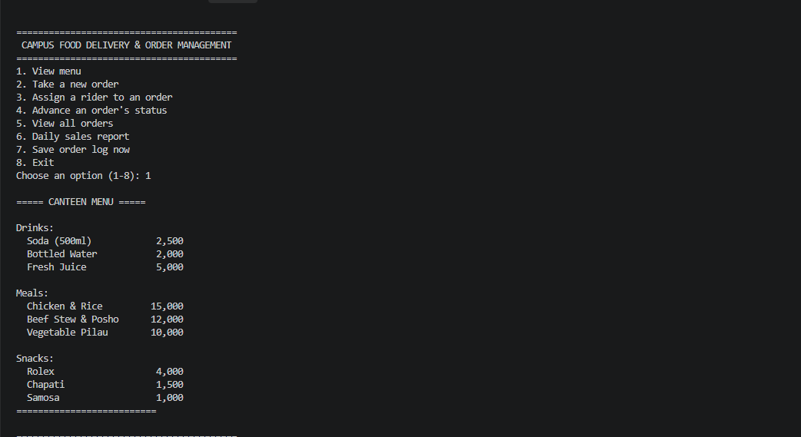

Canteen menu showing available drinks, meals, snacks and prices.
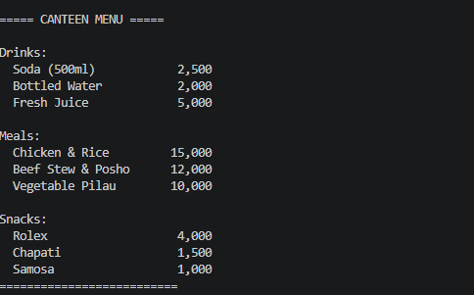
New-order screen shot showing selected item and quantity and Successful order placement showing subtotal, delivery fee and total.
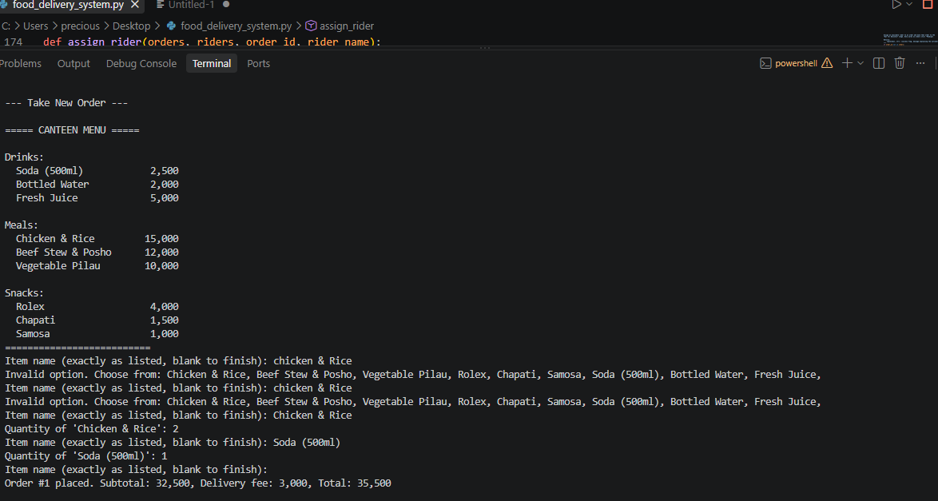
View All Orders showing recorded orders, statuses and rider information and Successful advancement of an order's status
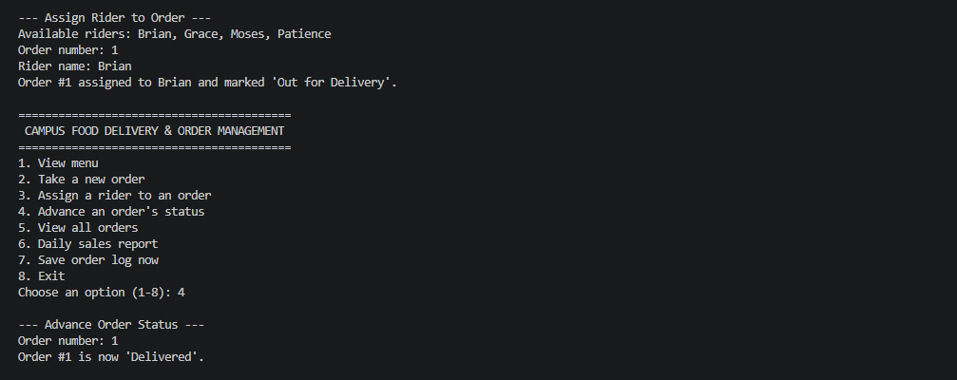

Daily Sales Report showing revenue, best-selling item and status counts.
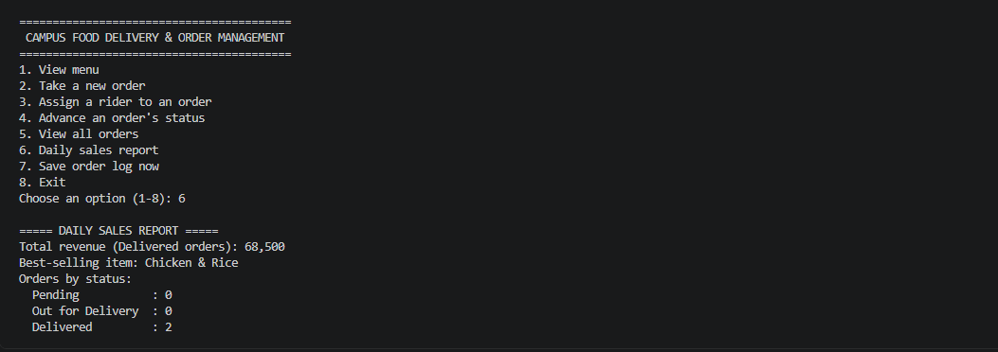
Successful saving of the order log and exit screen showing the Goodbye message and return to
